Decorator Pattern

Mandatory design patterns assignment

I4SWD

Christoffer Broberg au559138

Jakob Dybdahl au567226

Lars Holm au479361

Alexander Rasmussen au566287

# Purpose

# Type

# Structure

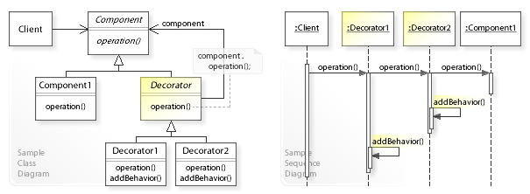

Se wiki [her](https://en.wikipedia.org/wiki/Decorator_pattern)

# Dynamics

# Consequences